G-3 Game code: Shark catching small fish
Program for shark to move towards mouse pointer and stay still if mouse is not moving
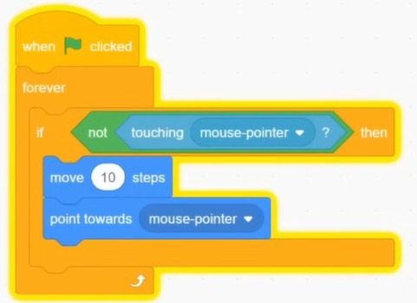
if shark is touching small fish use costume 2(mouth open) else (mouth close)
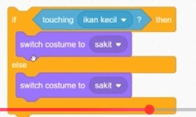
Small fish
Mouth shut
Mouth open
For the small fish
